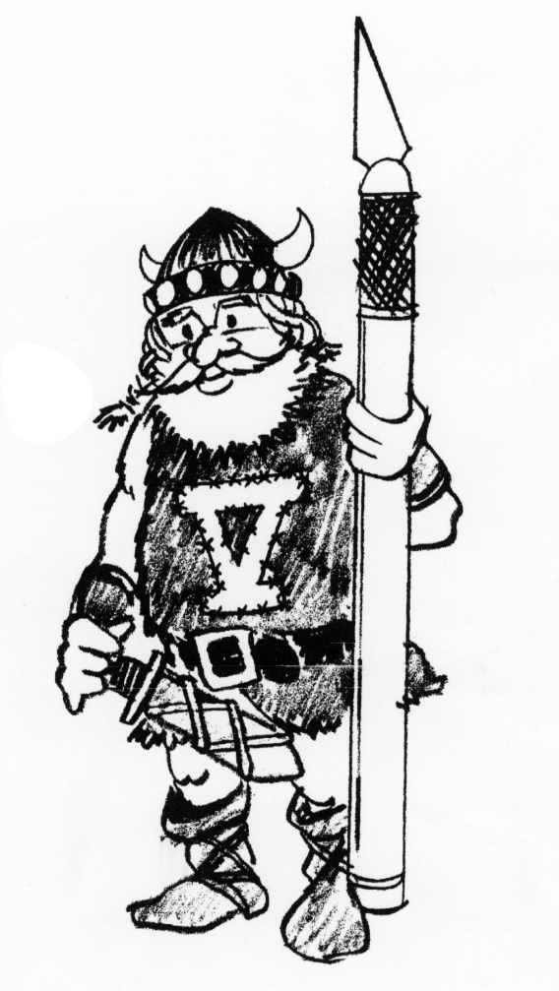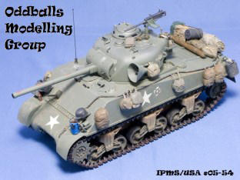
NordicCon Entry Registration Form
Category:
 |  |  | Open |  |  |  |  |  | Theme |  |  |  |  |  |  | Junior (18 and Under) |  |  |  |  |  |  |  |  |  | Display Only
Armor Category Only |  |  |  |  |  |  |  |  |  | Beginner |  |  |  |  |  |  | Intermediate |  |  |  |  |  |  |  | Advanced
Entry Number:
Model:
Scale:
Manufacturer:
STEP 1: |  | Complete one form for each model entered in show.
STEP 2: |  | DO NOT add Entry Number; this will be done by Registration Staff.
STEP 3: |  | After registering, place on the table with your model.
STEP 4: |  | Enjoy the show.
Modifications/Notes (brag box):

Category A - Juniors
A-1 | Ages 9 and Under
A-2 | Ages 10 to 13
A-3 | Ages 14 to 17
Category B - Aircraft
B-1 | WWI and Biplanes - All Scales
B-2 | 1/48 WWII Axis Single Engine
B-3 | 1/48 WWII Allied Single Engine
B-4 | 1/72 and smaller WWII Axis Single Engine
B-5 | 1/72 and smaller WWII Allied Single Engine
B-6 | 1/48 Multi-Engine
B-7 | 1/72 and smaller Multi-Engine
B-8 | 1/48 and larger Jets - Korea to Present
B-9 | 1/72 and smaller Jets - Korea to Present
B-10 | Helicopters (All scales)
B-11 | Post WWII Military Prop Planes (except 1/32nd scale)
B-12 | 1/144 and smaller - All
B-13 | 1/32 Aircraft - All
B-14 | Civilian (All Scales)
Category C - 0 - Armor | Please note there is only one category for Military Vehicle judging; that is C-0 Military Vehicles
Category D – Figures
D-1 | 54mm and Smaller
D-2 | 70mm and Larger
D-3 | Bust
D-4 | Sci-Fi and Fantasy
Category E – Ships
E-1 | 1/600 and Smaller
E-2 | 1/350 to 1/500
E-3 | 1/200 and Larger
E-4 | Submarines (All)
Category F – Automotive
F-1 | 1/18 and Larger – All
F-2 | 1/32 and Smaller – All
F-3 | 1/20 to 1/25 – Factory Stock
F-4 | 1/20 to 1/25 – Street Rods/Street Machines
F-5 | 1/20 to 1/25 – Customs
F-6 | 1/20 to 1/25 – Straight Line Competition
F-7 | 1/20 to 1/25 – Competition – Closed Wheel
F-8 | 1/20 to 1/25 – Competition – Open Wheel
F-9 | Trucks (2 and 3 Axel) – All
F-10 | Motorcycles – All
Category G – Sci-Fi
G-1 | All
Category H – Real Space
H-1 | All
Category I - Dioramas
I-1 | Military Subject
I-2 | Non-military Subject
Category J - Misc.,
J-1 | Miscellaneous
J-2 | Collections
J-3 | Trifecta

