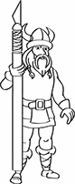 | NordicCon  Entry Registration  Form |  |  |  |  |  |  | 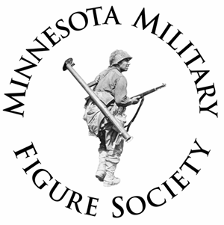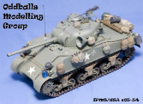
Category: | B - 5
 | X | Open |  | Theme |  | Junior (18 and under) |  |  | Display Only
Armor Category Only: |  |  |  | Beginner |  | Intermediate |  |  | Advanced
Entry Number:
Model: | P51-D Mustang
Scale: | 1/72
Manufacturer: | TAMIYA
STEP 1: | Complete one form for each model entered in show.
STEP 2: | DO NOT add Entry Number; this will be done by Registration Staff.
STEP 3: | Fold at dashed line to conceal your name from judges.
STEP 4: | After registering, place on table with your model.
Modifications / Notes (Brag Box):
Out Of The Box Build, Instructions displayed with finished model, painted with Tamiya paints.
SAMPLE FORM

