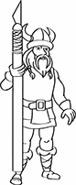 | NordicCon  Entry Registration  Form |  |  |  |  |  |  | 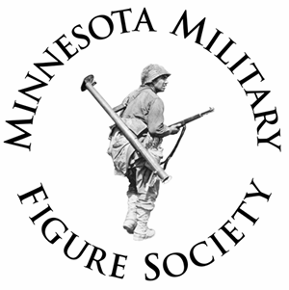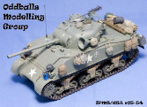  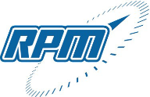
Category: | C - 0
 | X | Open |  | Theme |  | Junior (18 and under) |  |  | Display Only
Armor Category Only: |  |  |  | Beginner | X | Intermediate |  |  | Advanced
Entry Number:
Model: | Panther G (Late)
Scale: | 1/35
Manufacturer: | DRAGON “Smart Kit”
STEP 1: | Complete one form for each model entered in show.
STEP 2: | DO NOT add Entry Number; this will be done by Registration Staff.
STEP 3: | Fold at dashed line to conceal your name from judges.
STEP 4: | After registering, place on table with your model.
Modifications / Notes (Brag Box):
“Smart Kit” – Brush painted with enamels, weathered with water color washes and pastel powders, scratch metal camo loops on turret from wire, centerless grind steel wire antennae.
SAMPLE FORM

